Bugs Report
Front end:
Bug: Login successful but delayed – performance issue
- Description:
When I logged into the system with “performance_glitch_user” username and ”secret_sauce” password, i get successful login, but there is a noticeable delay before the dashboard loads. During this delay, the screen appears frozen or unresponsive for a few seconds. I can see that the system is reacting in the background, because the URL in the browser changes from the Login page to Inventory page.
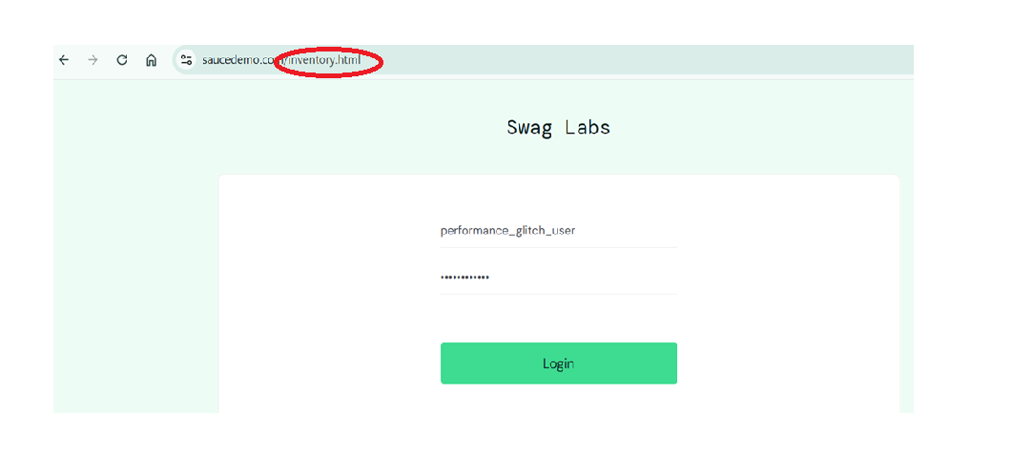
- Steps to reproduce
- Go to “ https://www.saucedemo.com”
- Log in with these credentials:
Username: performance_glitch_user
Password: secret_sauce
- Press the Login button

- Expected behavior
- Upon clicking the Login button with valid credentials, the user should be instantly redirected to the products page. The page should load smoothly, without any freezing or lag.

- Actual behavior
- After clicking the Login button with valid credentials, there is a noticeable delay of several seconds before the products page loads. During this delay, the screen appears frozen or unresponsive.

- Version:
Tested on Sauce Labs environment, 2025

- Severity: 4
The login functionality works correctly, but there is a noticeable issue that affects the user experience
- Priority: 3
The login delay affects user experience but does not block access.

Bug: Incorrect image on a product
- Description:
When I logged into the system with “visual_user” username and ”secret_sauce” password, i get successful login, but after logging in, the first product ( Sauce Labs Backpack) displays an incorrect image (a picture of a dog) instead of the correct product image.
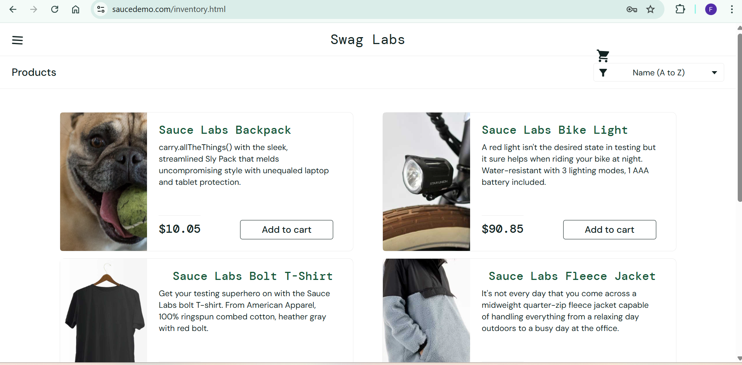

- Steps to reproduce
- Go to “ https://www.saucedemo.com”
- Log in with these credentials:
Username: visual_user
Password: secret_sauce
- Press the Login button

- Expected behavior:
- The first product ( Sauce Labs Backpack) should display the correct image of the backpack.

- Actual behavior
- The first product ( Sauce Labs Backpack) displays an incorrect image - a picture of a dog instead of the backpack.

- Version:
Tested on Sauce Labs environment, 2025
- Severity: 5
Incorrect product image negatively impacts user experience and may affect customer trust and sales.
- Priority 4

Bug: Prices change randomly upon each login
- Description:
When I logged into the system with “visual_user” username and ”secret_sauce” password, i get successful login, but however each time I log in, the product prices displayed on the page change randomly and are inconsistent.

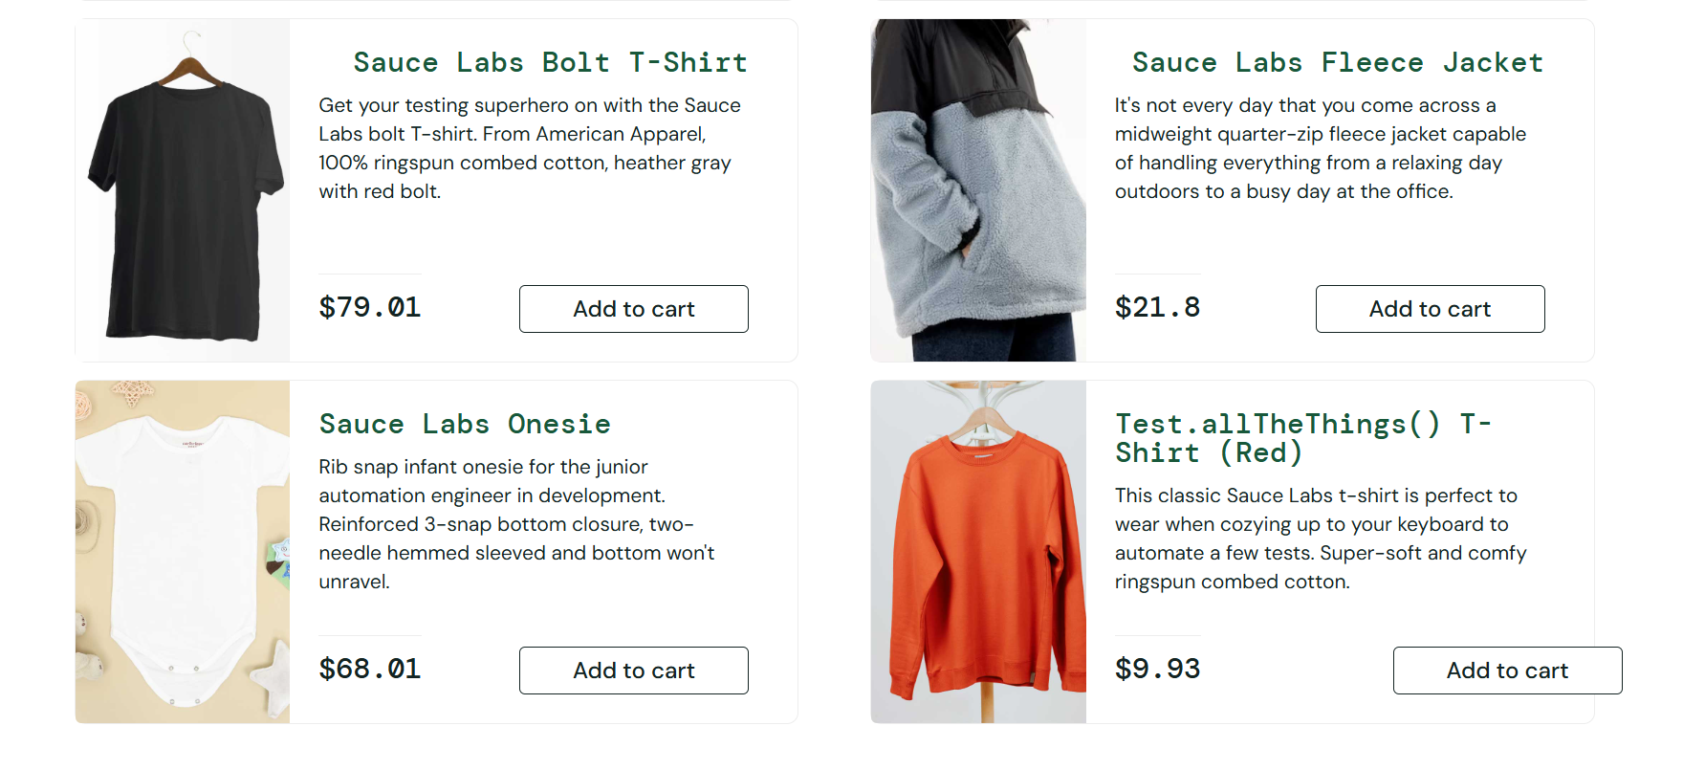
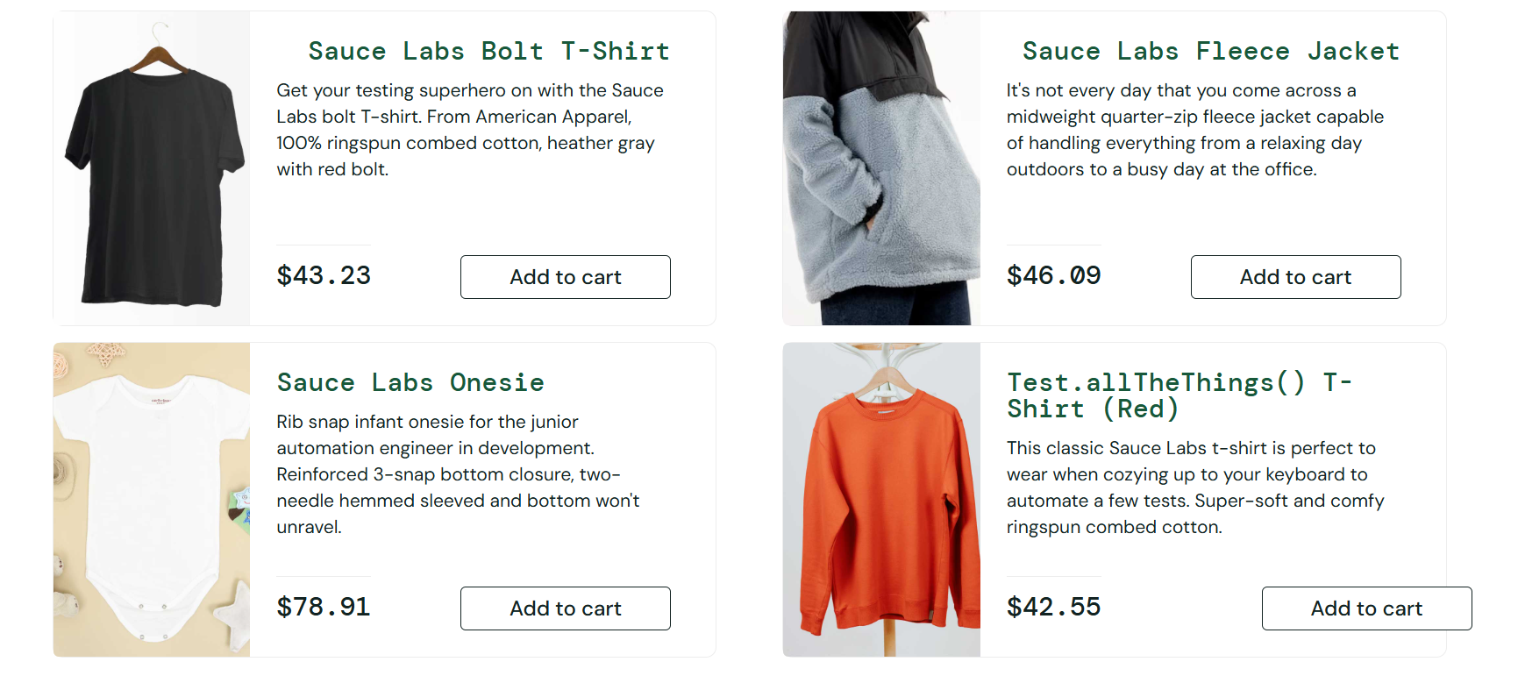

- Steps to reproduce
- Go to “ https://www.saucedemo.com”
- Log in with these credentials:
Username: visual_user
Password: secret_sauce
- Press the Login button

- Expected behavior:
The product prices should correspond correctly to their products and remain consistent every time the user logs in.

- Actual behavior:
Тhe product prices displayed on the page change randomly and are inconsistent every time the user logs in.

- Version:
Tested on Sauce Labs environment, 2025
- Severity: 5
Incorrect product pricing can lead to loss of customers and financial losses for the company

- Priority: 5

